Durack SS Pre-prep Program Daily Routine
8:55 | Arrival  Transition Teachers to welcome caregivers and children:  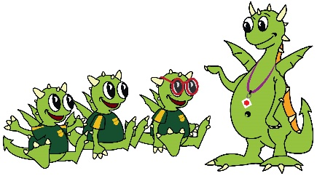  - find name tag and put on  - unpack bag e.g., drink, snack  - find name card and practice writing  - participate in good morning song  Song  Children complete jobs and settle on the carpet for ‘Good Morning’ song
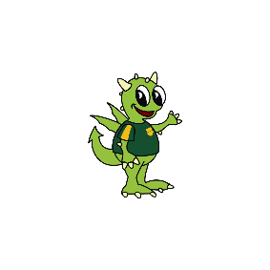  9:10 -  9:50 am | Fine Motor, Literacy & Math Activities  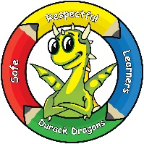  - Transition Teacher to introduce activities and assign students to tables. Digital timer is set for 8 minutes and rotations begin.  - Children move around to the three (3) activities (Math, English & Fine-motor)  - Parents/Carers support children as they participate in activities.
9:50- 10:00 am | 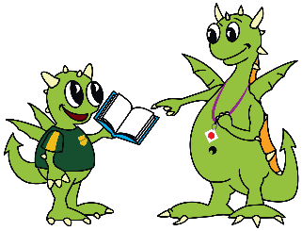  Group Time – Oral language and literacy concepts  - Children sit on the sit spots on the carpet  - Transition Teacher reads story, shares Story bridge program flash cards or engages children with literacy digital learning objects.  - Parents/Carers watch and help children to participate.
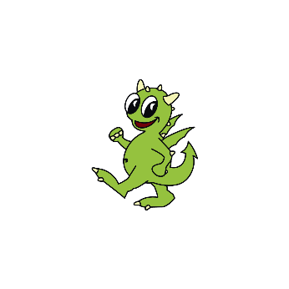  10:00-10:25 | 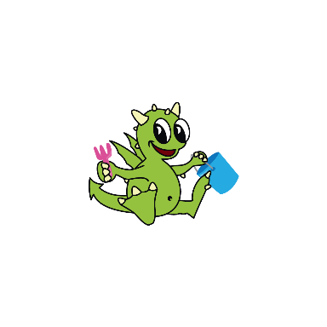  Toilet, Morning tea & Play time  - Children line up with their snack, drink and hat  - Children are reminded to use toilet if they need to before walking on to the Prep Eating Area  - Children sit at Prep A table and eat their morning tea  - Children pack up their lunch box and go to play.
10:25 – 10:25 am | Pack up  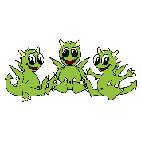  - Children pack up their bags and return their name tag to the trolley.  - They gather at carpet for reflection and messages  Song  Children sing the ‘Goodbye Song” and say good bye to their teachers and friends.
10:30 am | 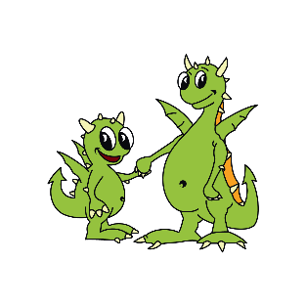  Home time  - Children are dismissed to their parents.

